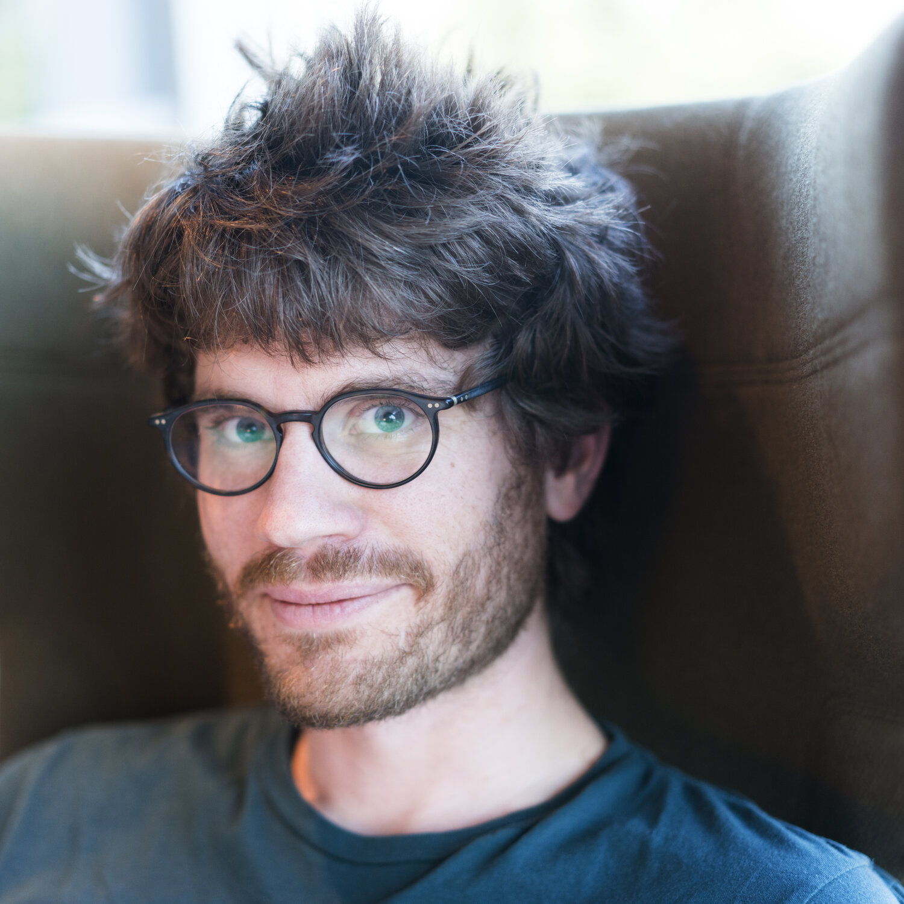

10 FEB

# Thomas Dimson

MSc Stanford University (USA)

Director of Engineering at Instagram



# Brianne Kent



10 MAR

PhD Cambridge University (UK)

Professor at Simon Fraser University



# Evan Browning

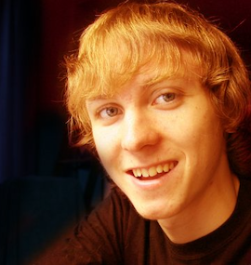

24 FEB

BSc University of Toronto

Senior Software Engineer at Netflix



# Ahmed Omran

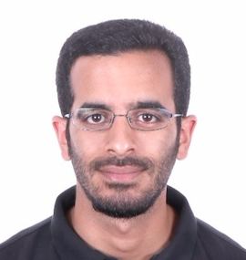

12 MAY

PhD LMU Munich (Germany)

Artificial Intelligence Resident at Google



# Leonard Zgrablic

14 APR

BSc University of Waterloo

Software Engineer at Google

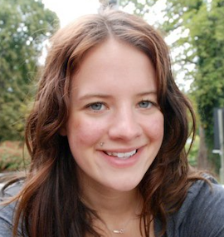

# Genevieve Laurier

16 JUN

MSc Oxford University (UK)

Managing Director at The Social Innovation Partnership



HPQC College



2021 Lecture Series